Azure ARM RDS Farm Deployment

**Prerequisites:**

1. A valid Azure user account with Azure Subscription.
2. User Account should have permissions to create Resources on ARM portal.

**Process:**

Estimated Time to Complete: (2 hour)

* Login to Azure portal URL: <https://portal.azure.com> with your valid credentials.
* Deploying Basic RDS Farm on Azure ARM.

Please use the Basic RDS Farm ARM Template

URL: <https://azure.microsoft.com/en-us/resources/templates/?term=rd>

Select **Basic RDS farm deployment**

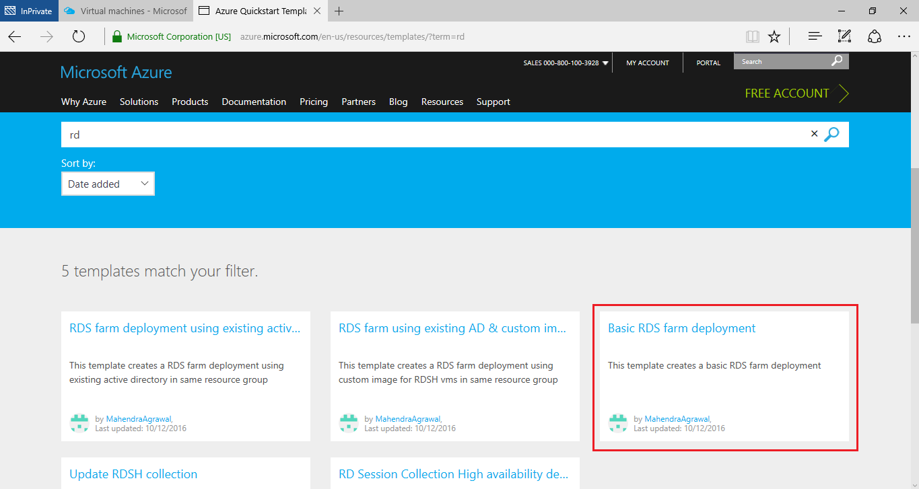

* Click on **Deploy to Azure**

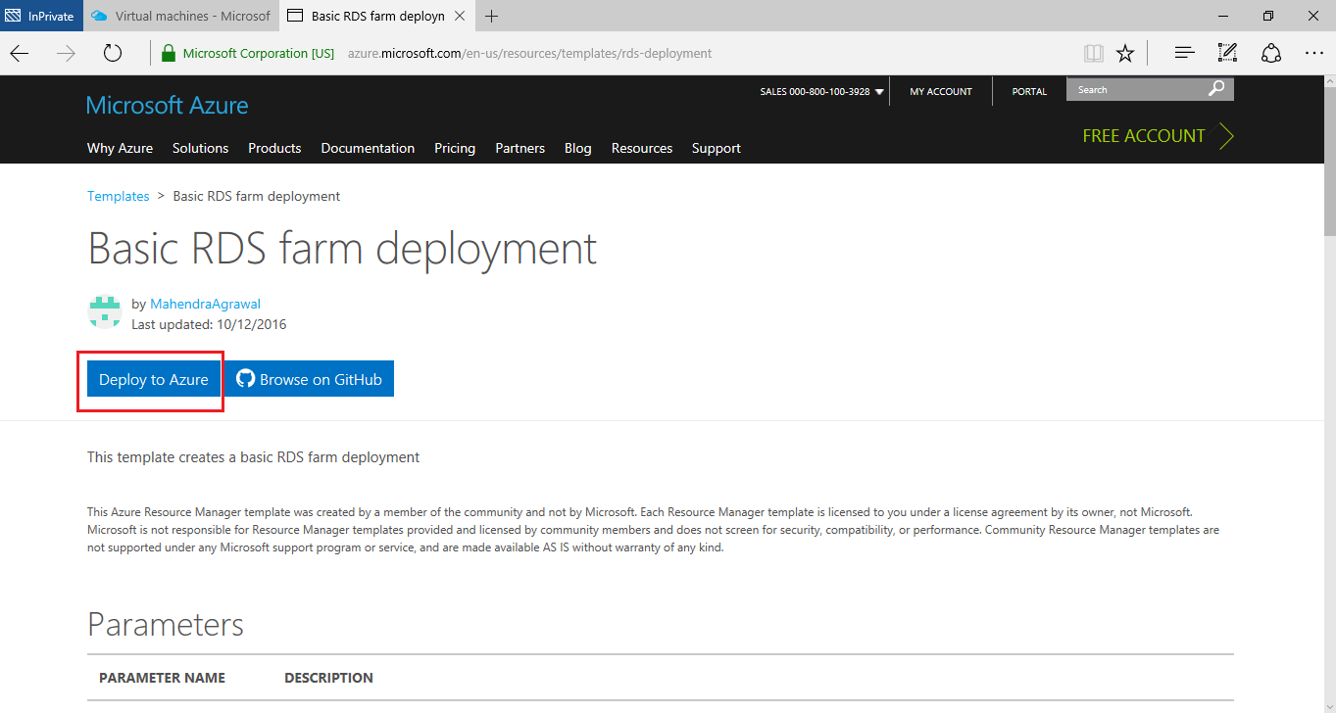

Once selected you will navigated be to Azure ARM portal, if you are already logged in and opened above URL in same Azure portal browser you should directly landing on ARM Template Deployment Page on Azure.

Please provide the Basic details:

1. **Subscription**: Select the Existing the subscription for Deployment.
2. **Resource Group**: Select Create new and Provide a Name for Resource Group.
3. **Location**: Select the location which is near to customer base.

Please provide the Settings details:

1. **Gwdns Lable Prfix**: provide the Gateway server DNS name which should be unique.
2. **Gwpublis IP Address**: Can be set to Default.
3. **Ad Domain Name**: Provide the Domain Name
4. **Admin Username**: Provide the Admin Username
5. **Admin Password**: Provide the Admin Password
6. **Image SKU**: Select the 2012-R2-Datacenter
7. **Number Of Rdsh Instances** : Provide the number of required RDSH instances to deploy.
8. **Rdsh Vm Size**: select the RDSH instance VM size (Testing purpose selected Standard_A1)

Once the required details are provided, Go through the Terms and Conditions and Accept. Click on **Purchase** Button

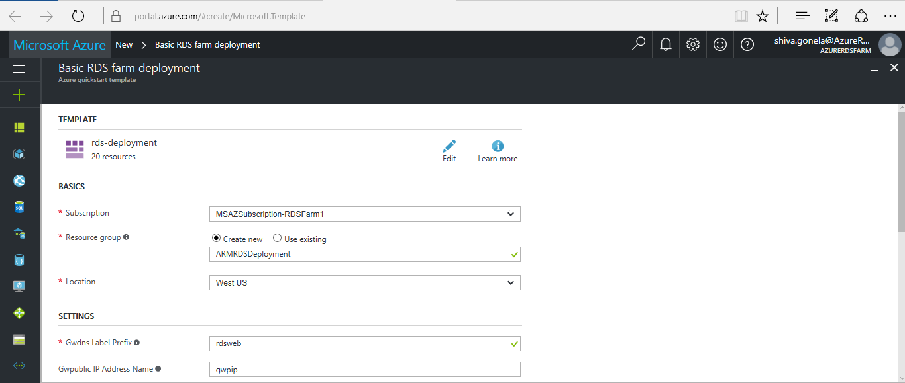

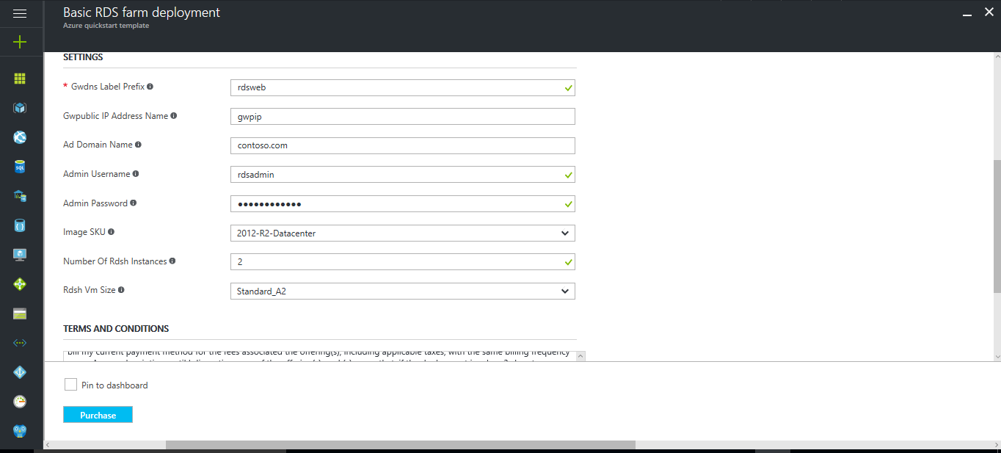

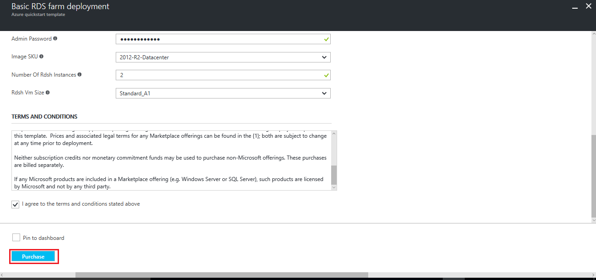

**Validation Process and Deployment Status:**

Once you click on Purchase the ARM Template will be validated and you can track the progress.

You can get complete track on deployment process by clicking on the deployment status.

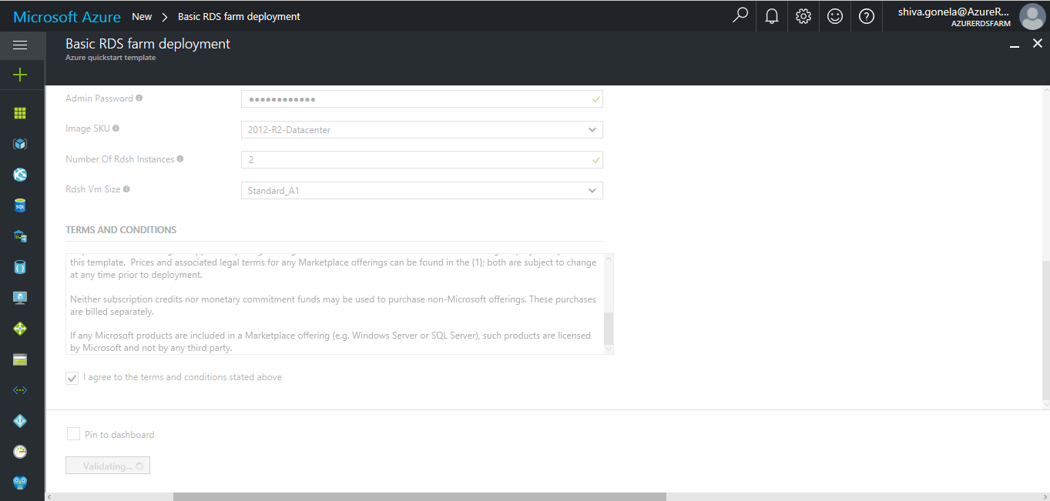

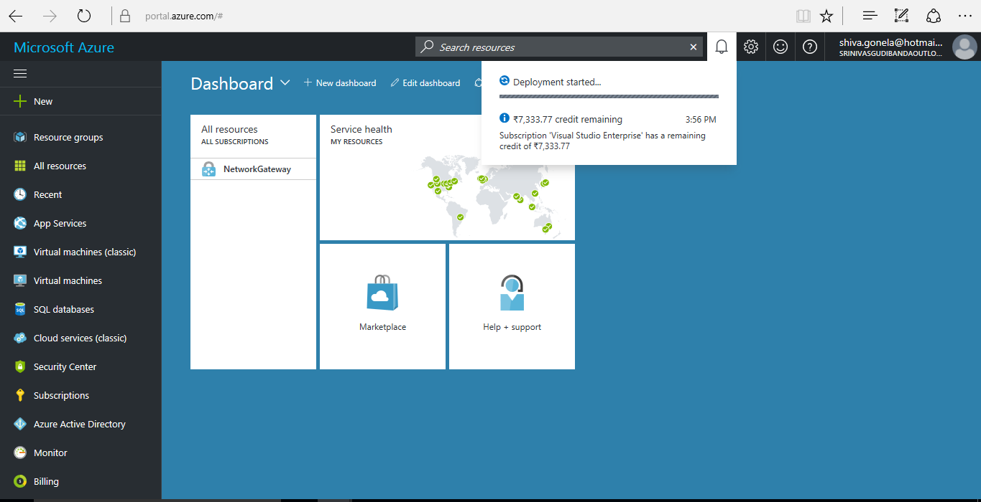

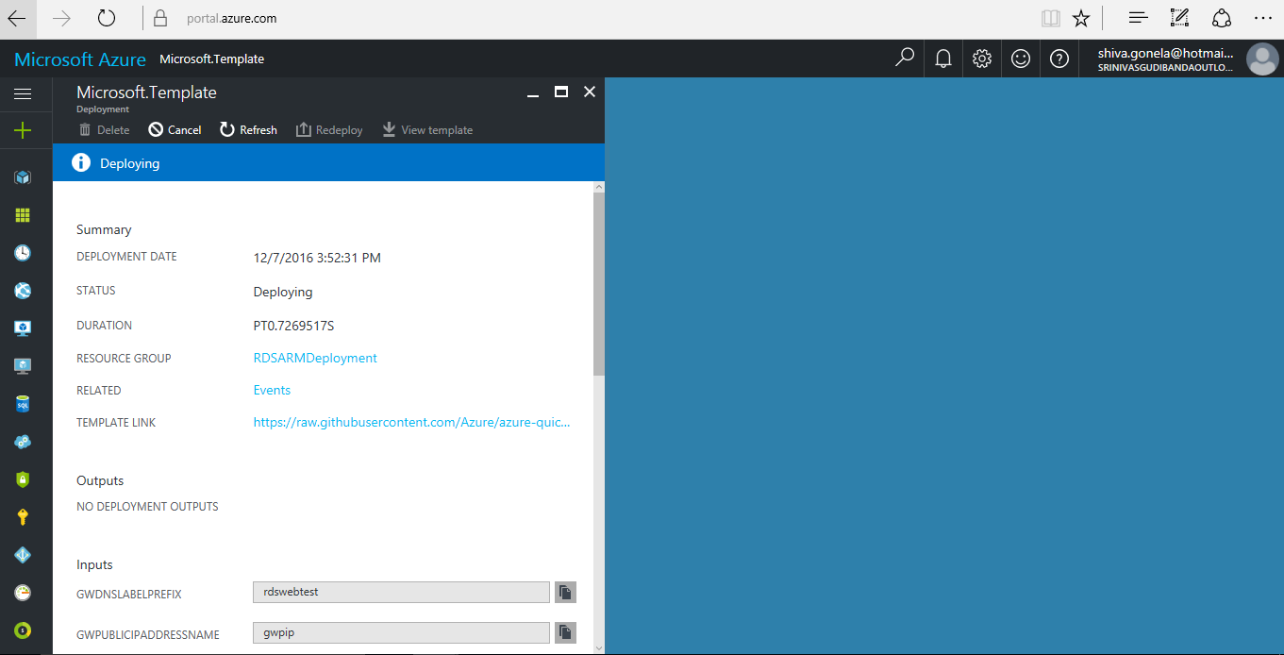

* Once Deployment is successful, you can check the Deployment Status Summary.

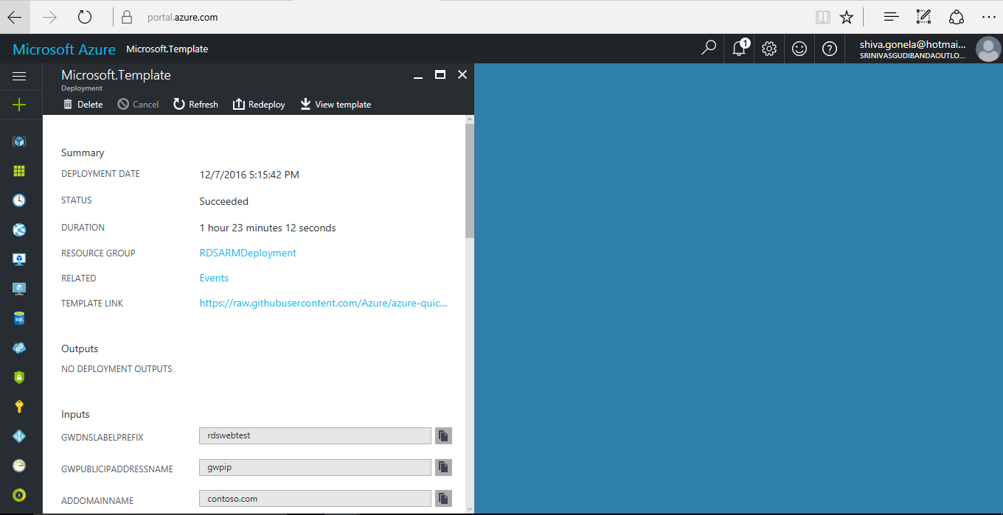

**Check the Virtual Machines:**

GoTo🡪 Click on Virtual Machines 🡪 select gw-vm (Gateway Server) 🡪 Copy the DNS Name Label (In my case it’s “**rdswebtest.southeastasia.cloudapp.azure.com**”)

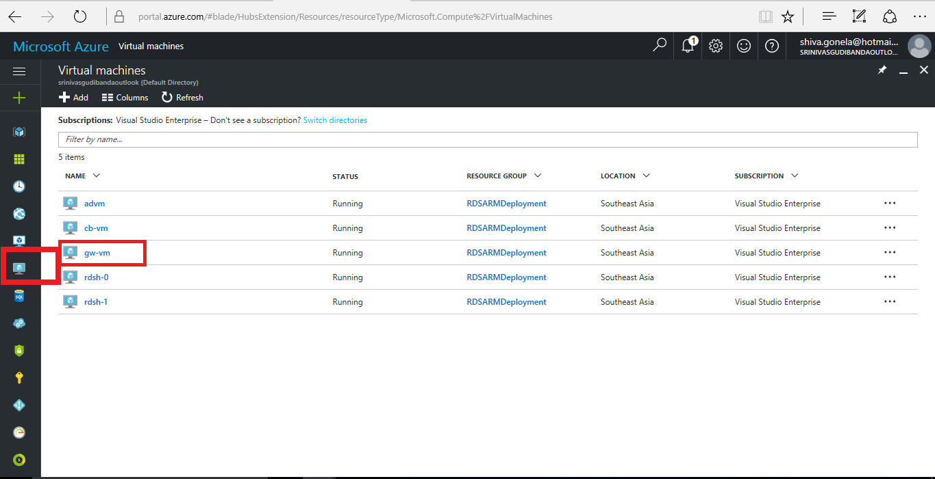

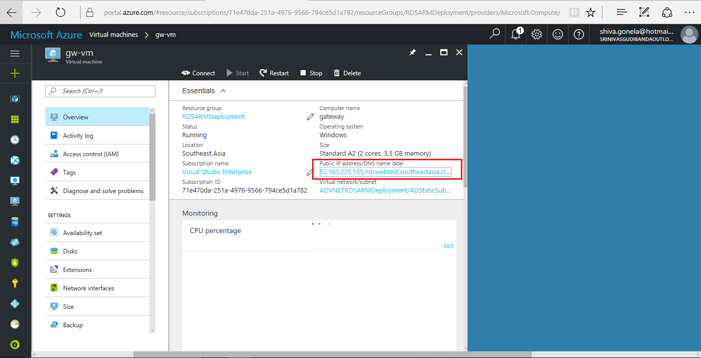

**Testing RDS Web:**

* The RDS Web will be configured on IIS of Gateway Server (gw-vm) with RDWeb Directory path.

Note: gw-vm is configured with both Gateway server role and Web Access role.

* The Web Access URL will be “https:// gw-vm DNS Name Label /RDWeb” in my case ( <https://rdswebtest.southeastasia.cloudapp.azure.com/RDWeb>)
* Copy the link in browser to access RDWeb
* Please ignore the certificate issues as we have not configured. We can store the certificate locally to authenticate.
* Click on Continue to this webpage (not recommended)

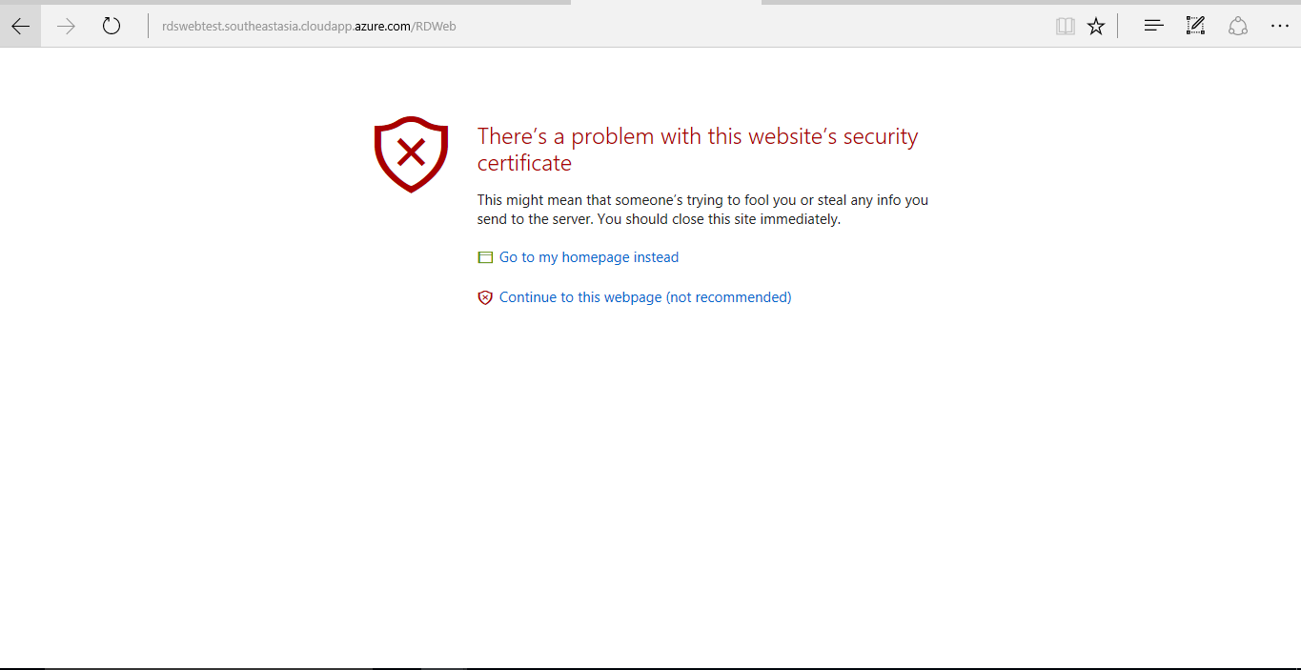

* Provide the Username and Password. The one which we have used while deploying the RDS Template.
* You must provide the domain name followed by username (Domain\user name) and password.
* Click on **Sign in Button**

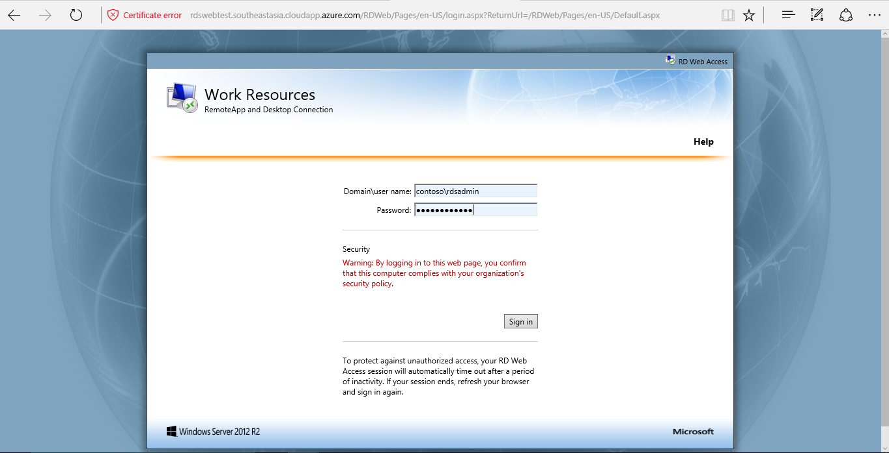

* Values given during RDS ARM Template (Domain Name, Admin Username, Admin Password)

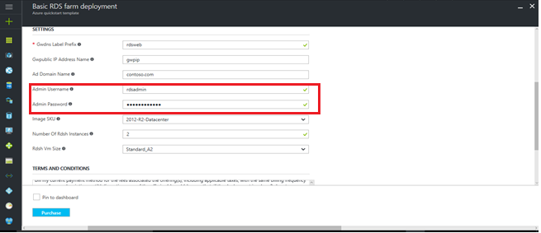

* On successful sign in process you should get the below screen with Remote Desktop

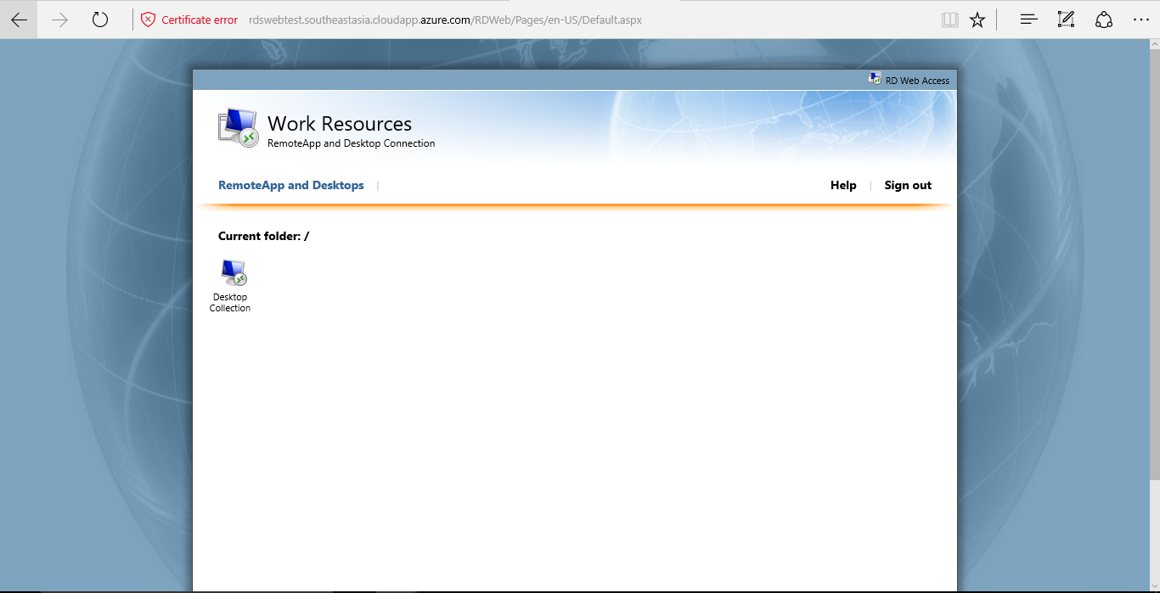

**Adding local certificate and Accessing Remote Desktop**

* Click on Desktop Collection icon
* A .rdp file will be downloaded, save the file and open.

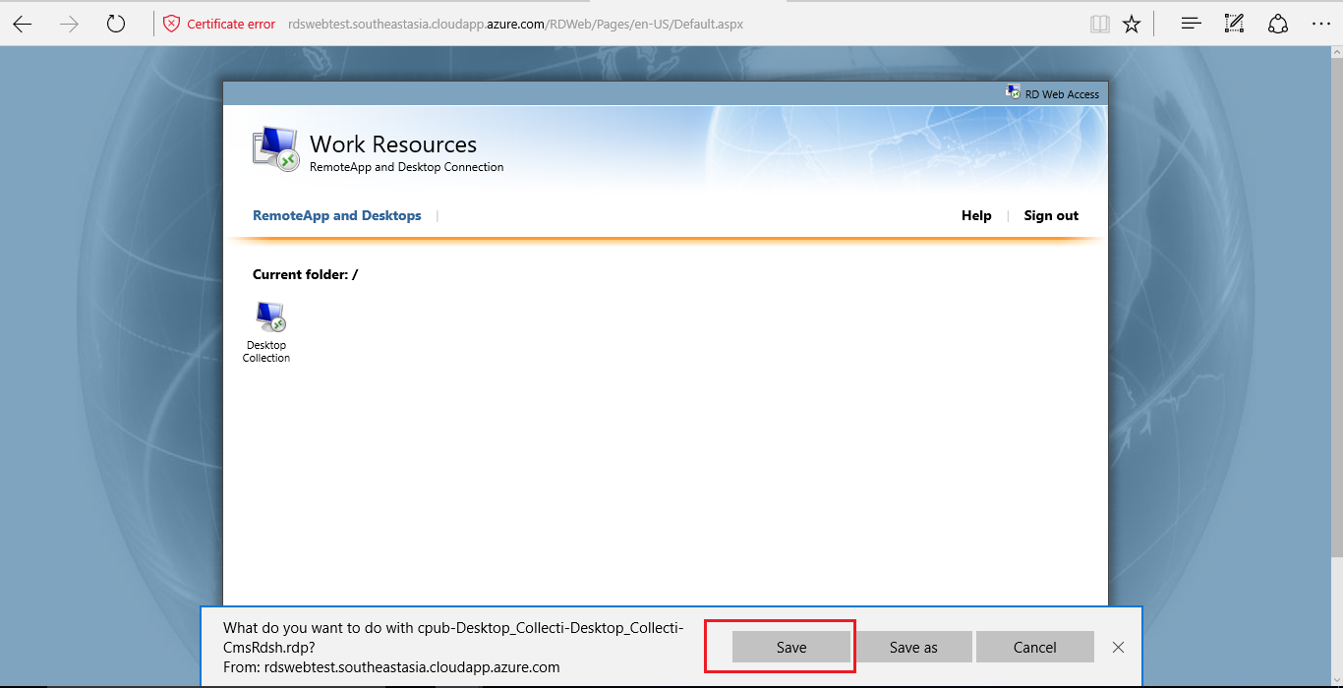

* Click on Connect

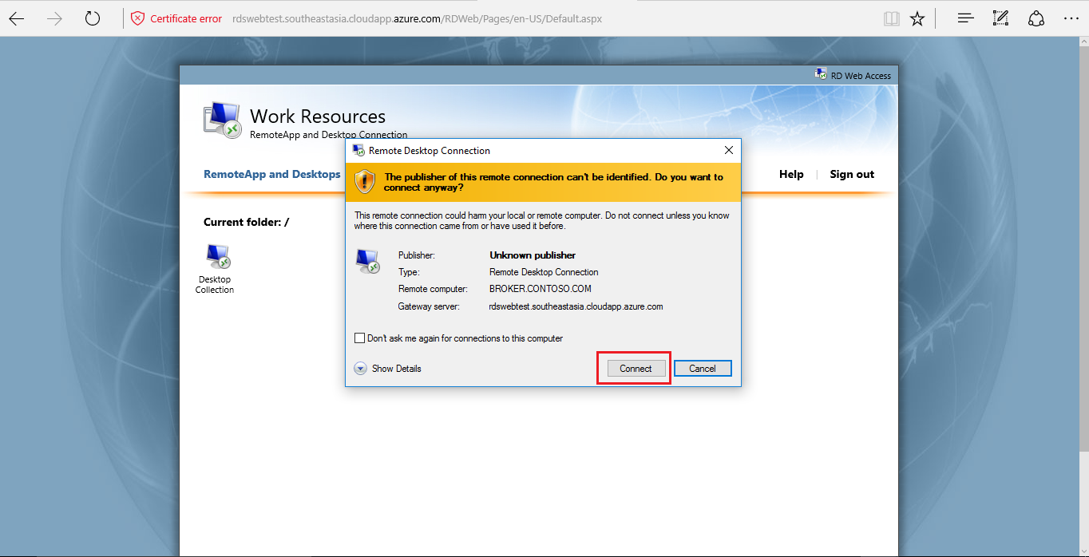

* It will prompt for Entering the credentials to Access the Remote Desktop, provide the details that are used to login to RDWeb and click on OK.

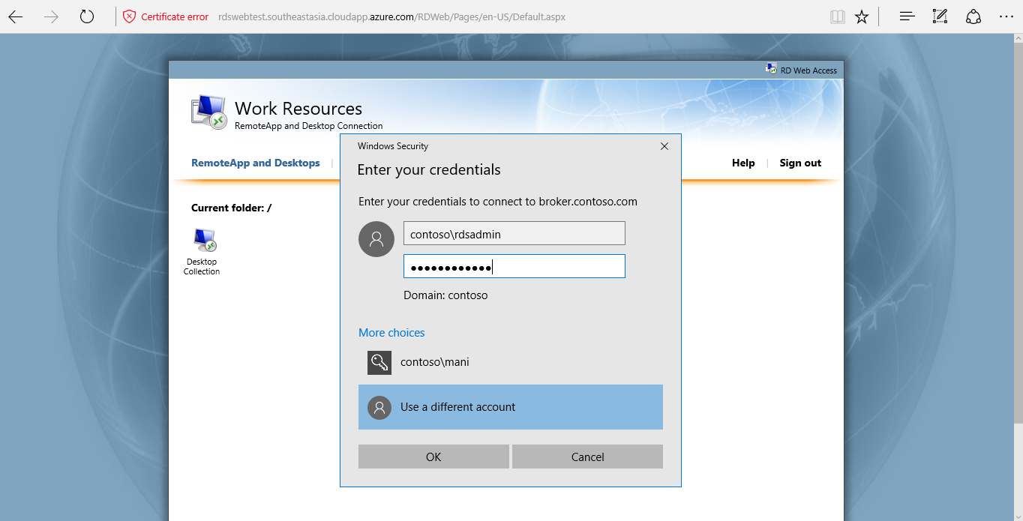

* You will be prompted with certificate issue. Click on View Certificate to copy the certificate locally for authorization.

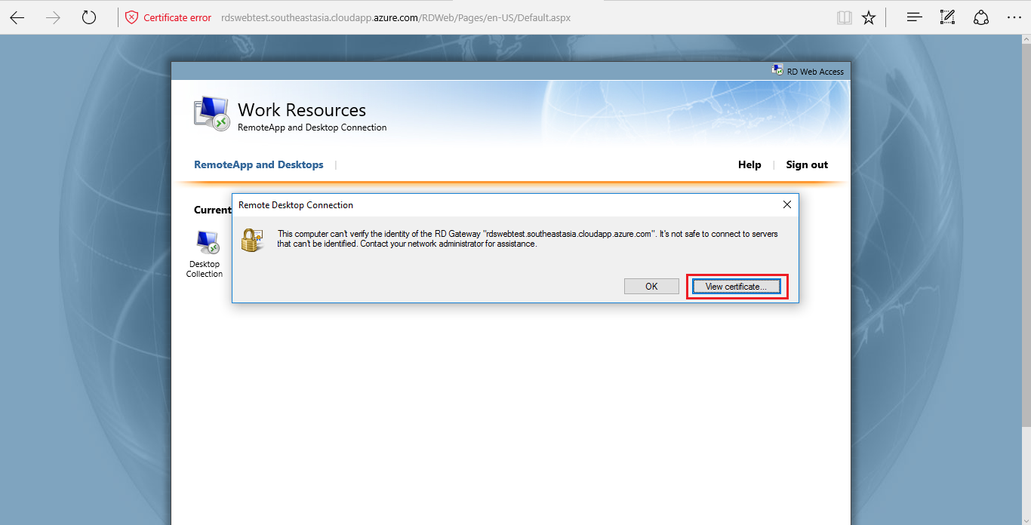

* Click on details Tab 🡪 Copy to File

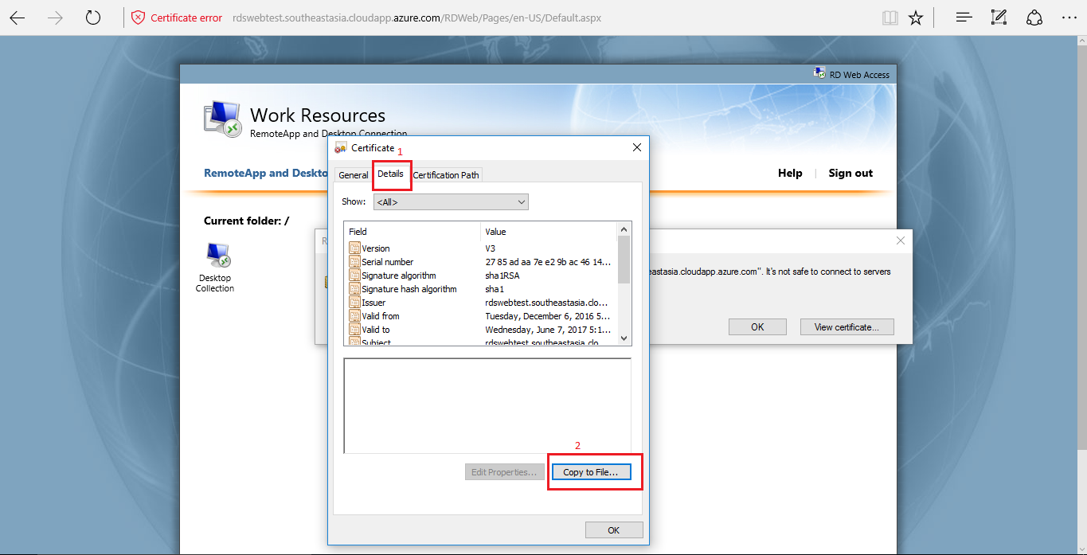

* You will be prompted with Certificate Export Wizard,click **Next and follow the below process as in screens.**

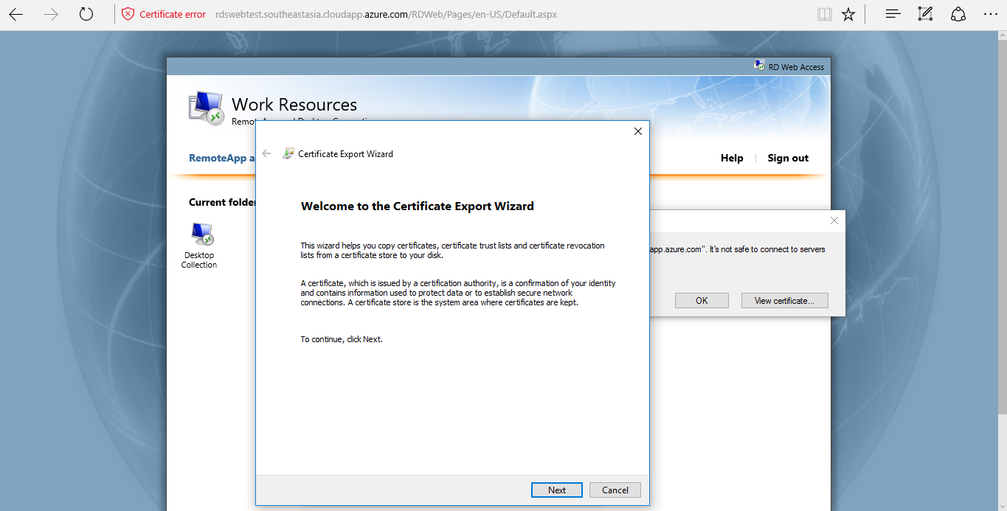

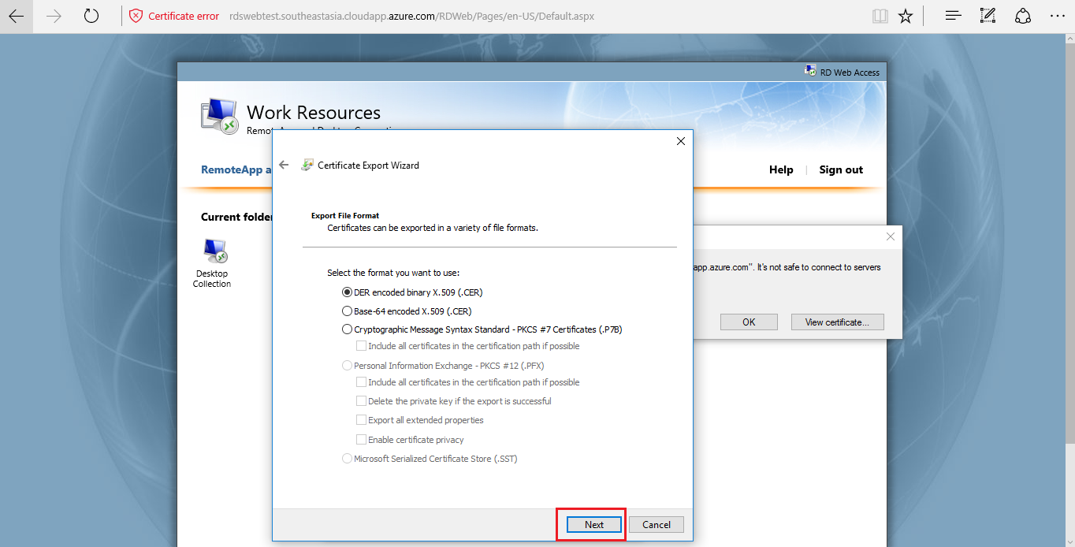

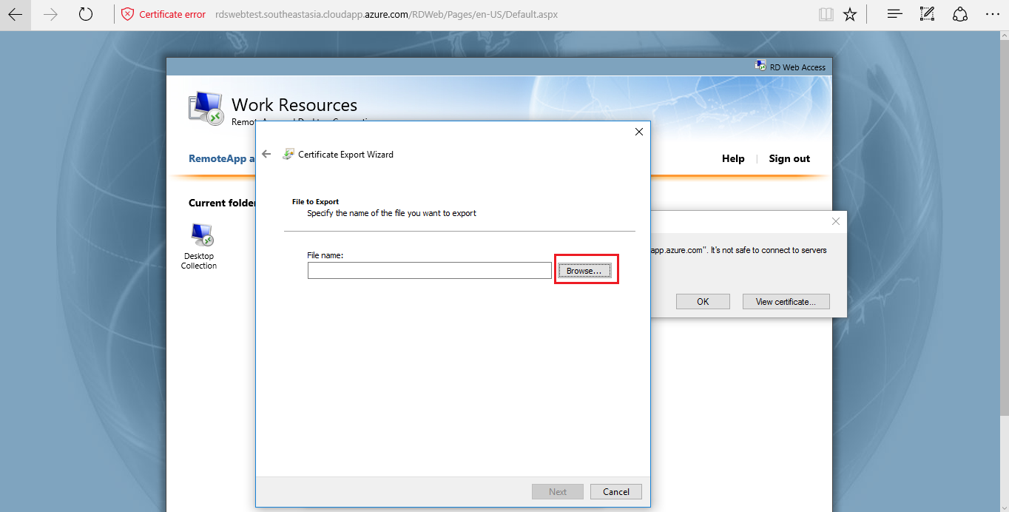

* Select the location to store the exported certificate on local system.

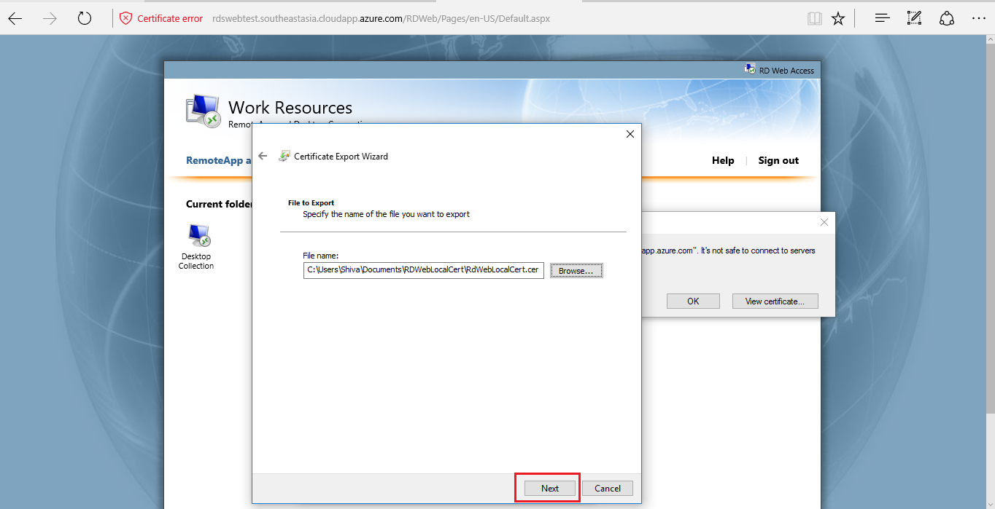

* Click on **Finish and OK**

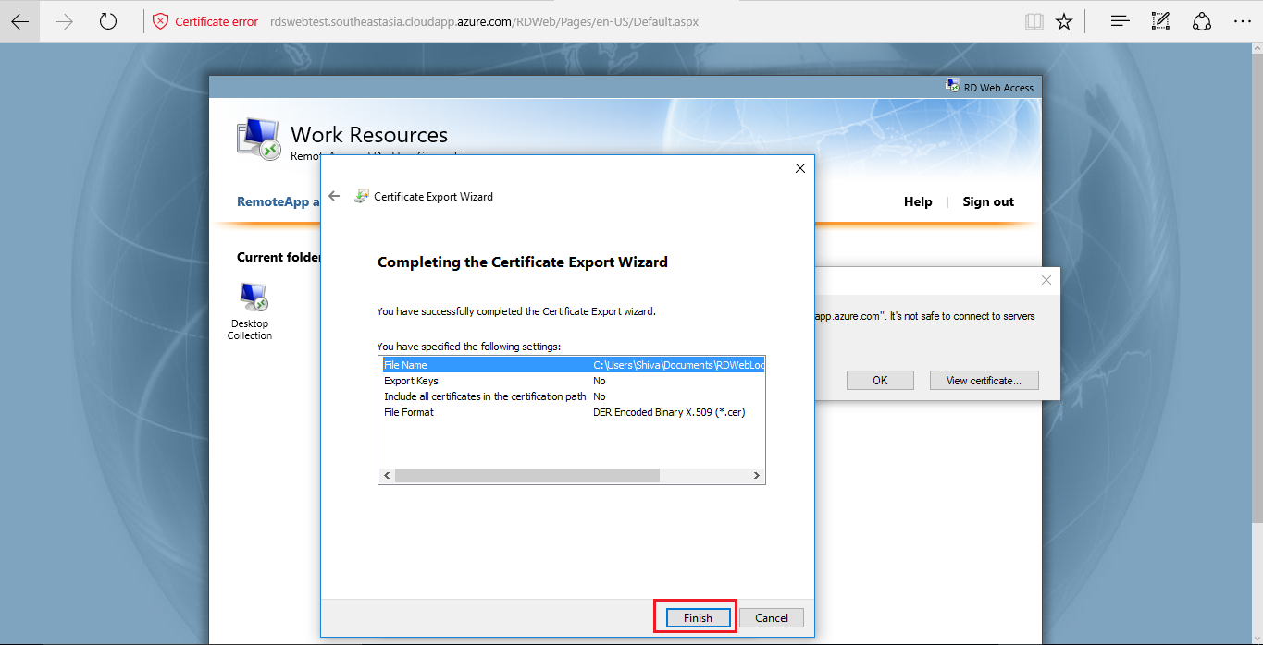

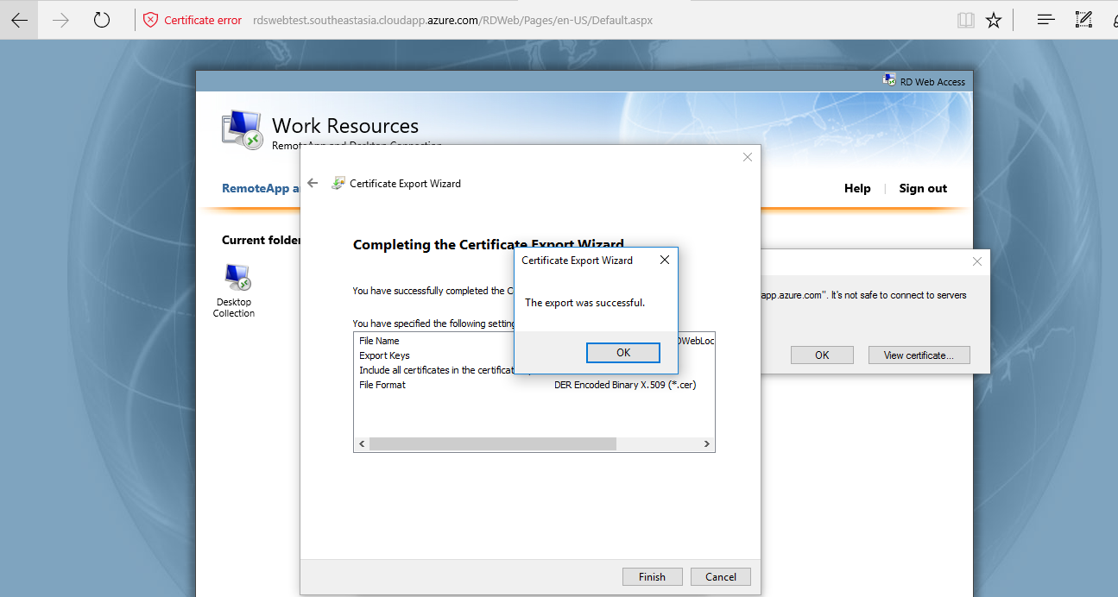

* Browse to the location where we have exported the certificate. We must install the exported certificate to local certificate directory. Follow the below process.

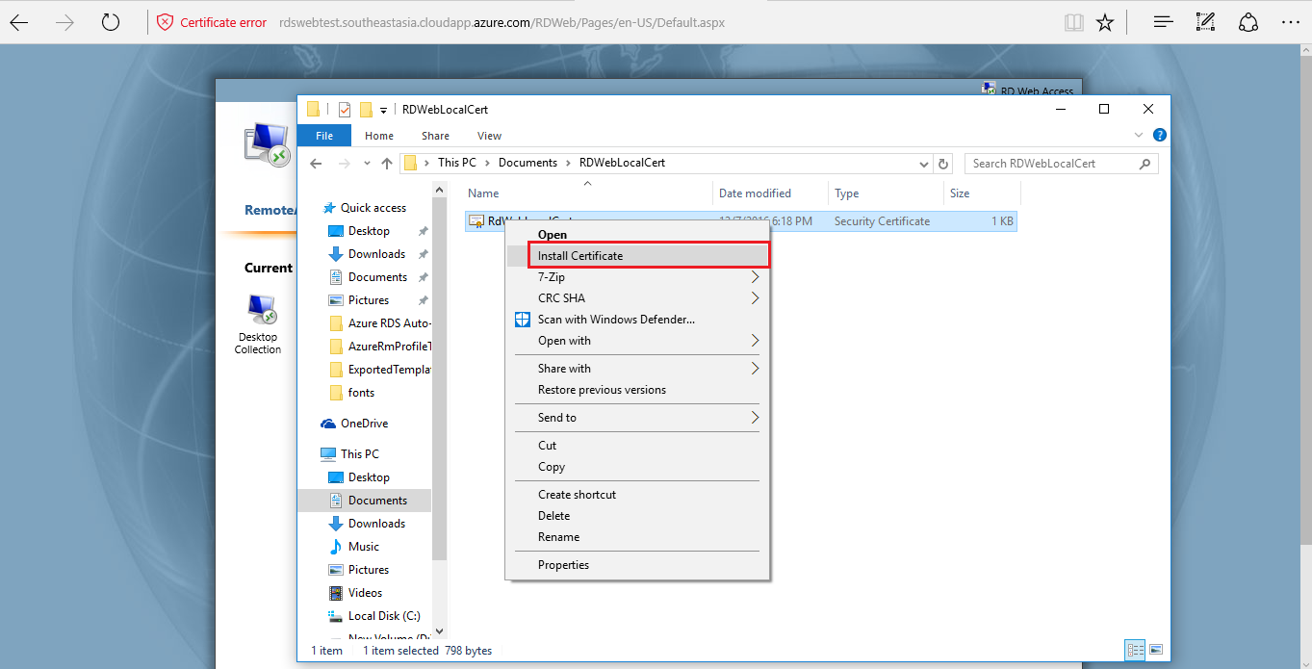

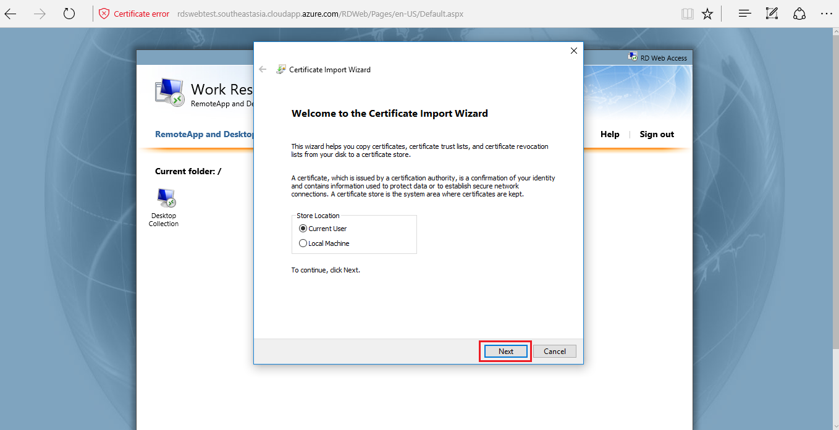

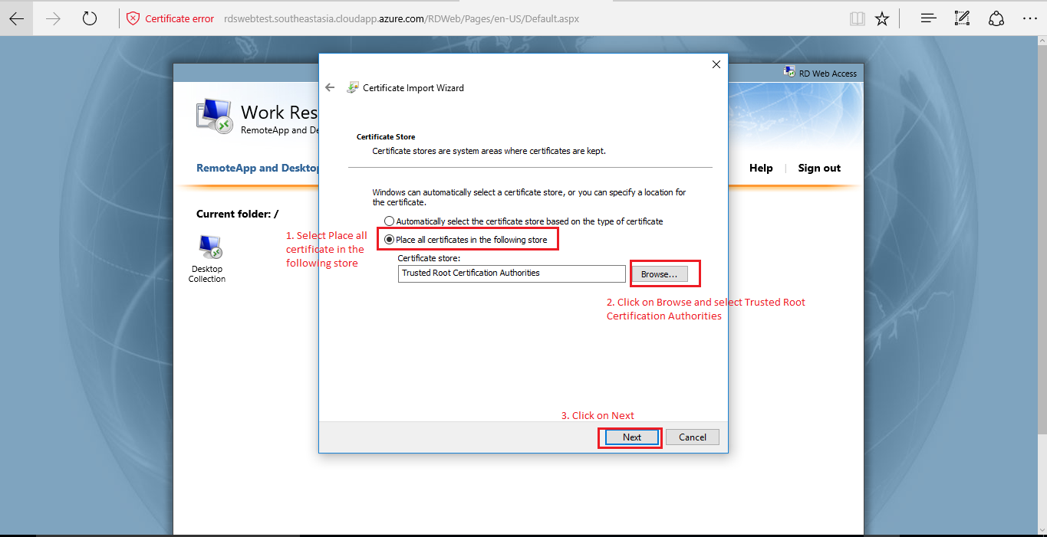

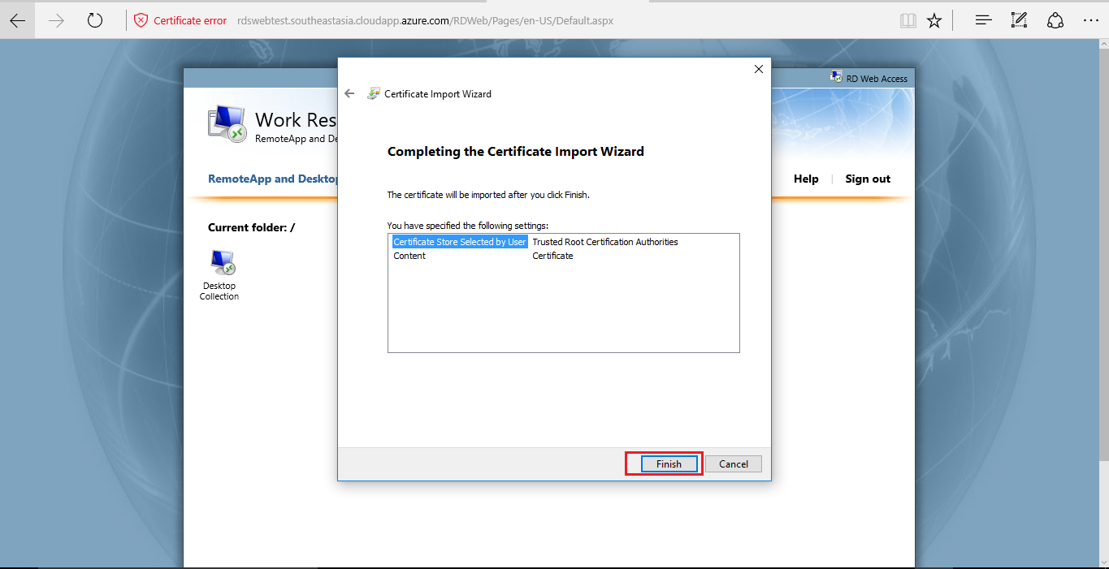

* You will get security warning, click on Yes and then Ok

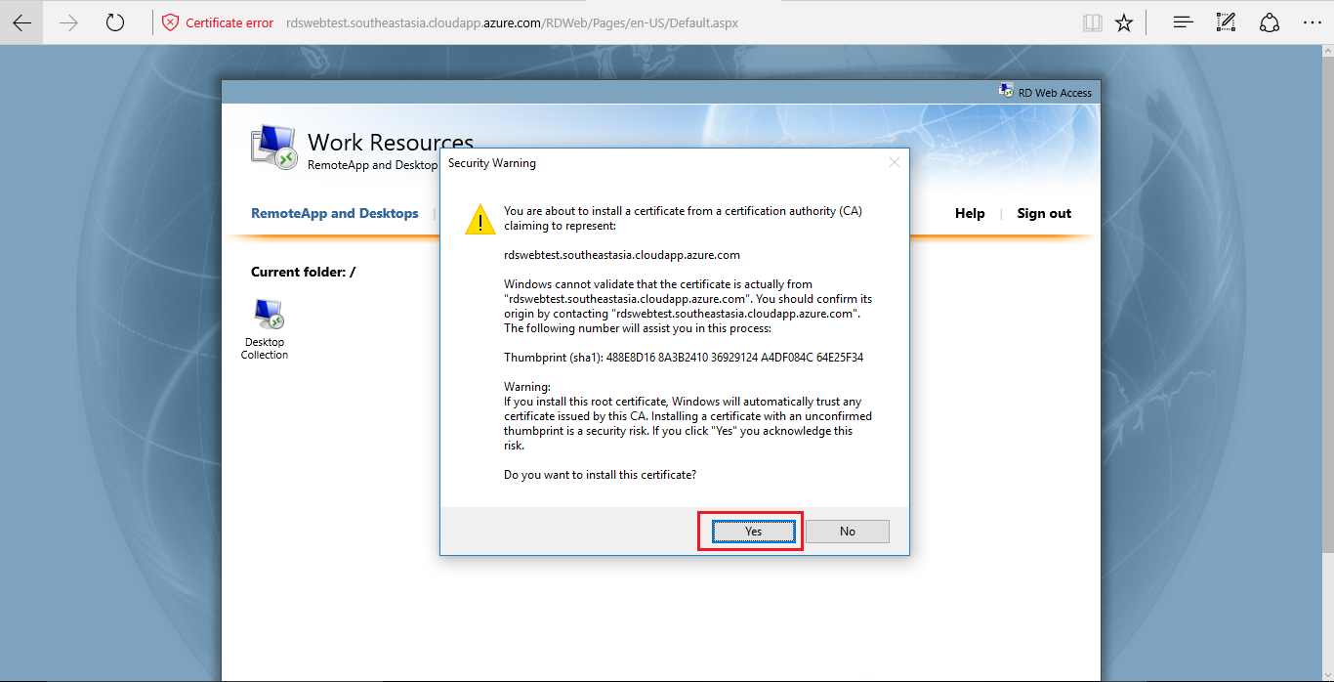

* Now go back and try to open the .rdp file which was downloaded earlier to access Desktop Collection. Enter the credentials.

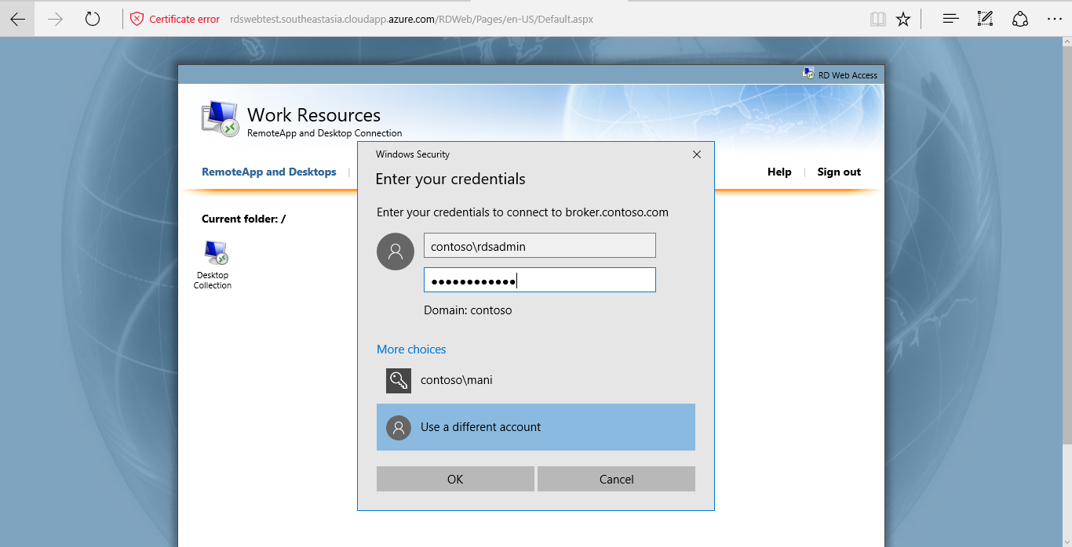

* This time it will be pass through the certificate issue, click on Yes.

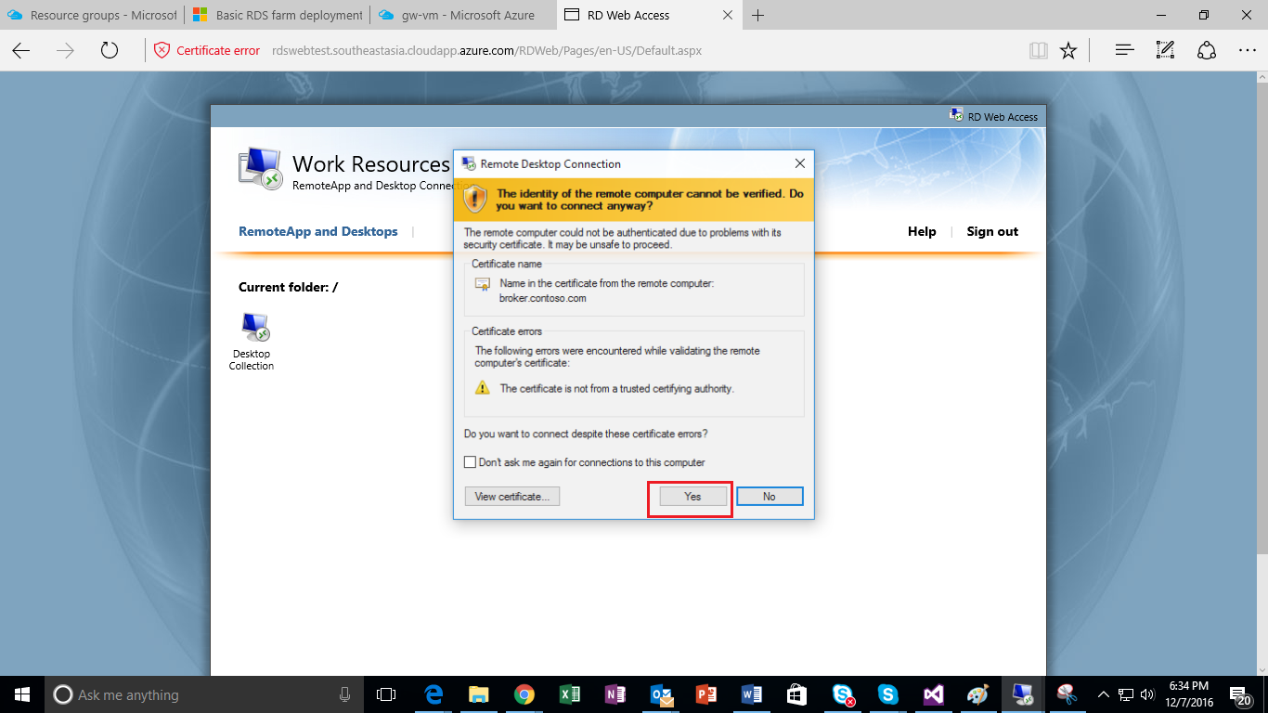

* **Finally, you will be Successfully connected to Remote Desktop server ☺**

